Name: He calls himself Shin Shining/ real name Asta

age: unknown

personality: happy go lucky, laughs a lot, never serious(never needs to be), isn’t a goofball. He doesn’t take many things seriously and rather not show off his skills. He is carefree and relaxes a lot and can’t help but to always remember his past struggles (stares off at distances often). Often crack jokes and give hints

appearance: (Asta)cool, (Shin)not as cool. (subject to change)

backstory: He is a famous person years ago for being the best of the best/ world champion. He struggled his way to the very top, so he knows how tough the journey was. There are legends about him and everyone knows of his name/title. He was the cofounder of team Oysha. He decided it was too boring at the top since he yearns to experience the journey of struggling once again so he hid his identity and secretly decided to go to low ranks. He doesn’t talk about his past. He attempts to never reveal his identity. He has lost a lot of friends while rising to the top. He has seen so many people losing hope and quitting.

rank: Onyx/ for shin shining claims: it’s whatever the main character is

strength: He is insanely powerful and can take out people so fast that they nor anyone around them could see it happen. Wields a gun and a sword. Said to be able to use a sword with one hand equal to another person using two swords. Create mirage images just by swinging a sword.

interaction with main character:

When he meets mainCharacter, he notices that the main character was panicking so he tries to him out. Eventually, he sees mainCharacter to be interesting so he stays nearby mainCharacter thinking that it would be fun and interesting. Through certain dialogue choices mainCharacter might figure out Shin Shining’s real identity. If he deems the main character worthy enough he will instant kill the final boss and challenges the main character immediately. If mainCharacter chooses a dark route, Asta will appear at the end and tries his best to stop him, atmosphere will become very different.

likes: sushi,

dislikes: He feels depress when he sees someone lose hope.

Habits: often blanking out (remembering past events)

Goals: Finding entertainment

Character inspiration:

He is actually the main character of a story that I wanted to make.

Has some of my traits mixes with anime inspiration

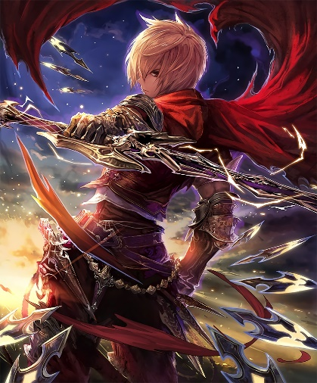

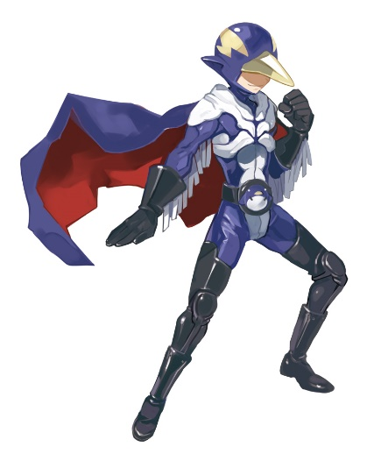 Asta

Shin Shining